Electronic ballast SINECAN 5 for two fluorescent tubes has identical circuit like most of compact fluorescent lamps. Little differency is in powering tubes before D6 diode and wiring of start capacitors C10 a C11 about tubes. I don't understand exactly why this is wired this way. Ballast doesn't have fuse, but only thin wire. Ballasts was broken due to blowed electrolytic capacitors. It breaks transistors and resistors R3, R4, R5 and R6. 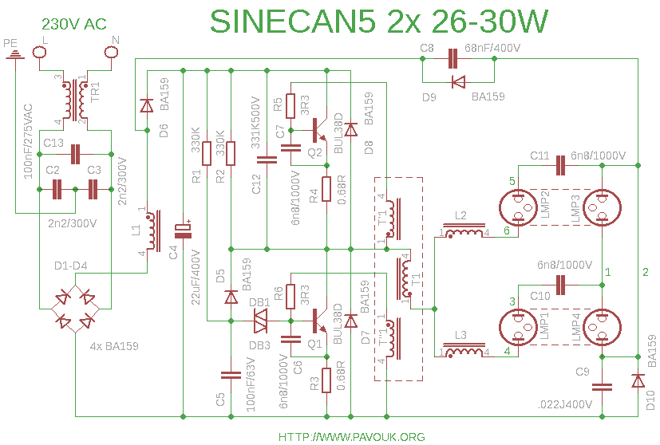
Photography of open ballast.
