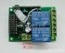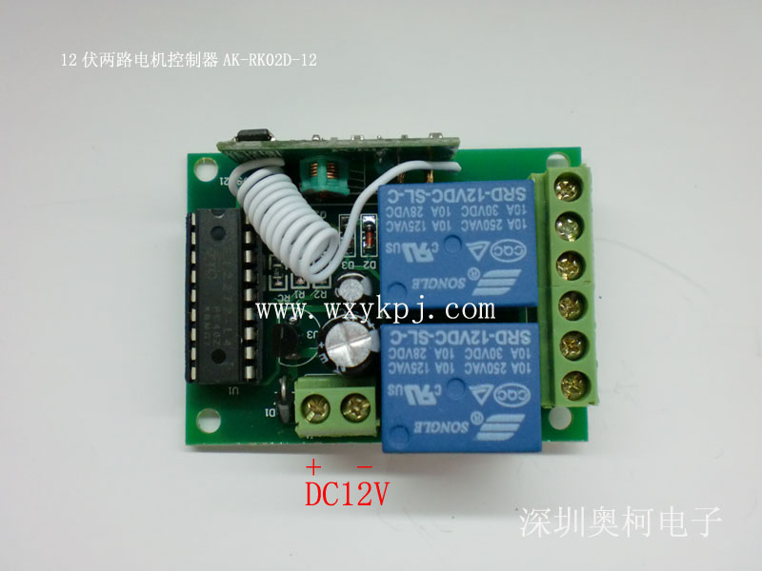

AK-RK02A-12 12伏两路遥控开关（带蜂鸣器）
Model：AK-RK02A-12
Name: 12V 2-channel remote switch (with buzzer)
Retail price: USD 6.5
Wholesale price: USD 4.4
Agent price: USD 3.1

Working voltage: DC 220V
Working frequency: 315-433MHZ
Maximum load; 10A
Receive sensitivity: -100dB
Coding type: fixed code
Working way: jog , inter-lock .self- lock (with IC connector)
Output way: Two groups of switch signals

Brief Description:
1. The remote switch with an IC sockets, and it is easy to change its function. If you want to change the inter-lock to self-lock, you just only change the L4 chip toT4 chip.
2. Set aside bit location to adjust the welding point, it can get rid of the trouble of changing remote control’s circuit.
3. It is convenient for measuring the working state with buzzer.

